**Curriculum Vitae (CV) Personal Information:**

**Name:** Prof. Christos D. Papageorgiou  
**Address:** Nymfon 1b, 14563 Kifissia, Athens, Greece  
**Phone:** +30 6937-377-998  
**Email:** [chrpapag@gmail.com](mailto:chrpapag@gmail.com)

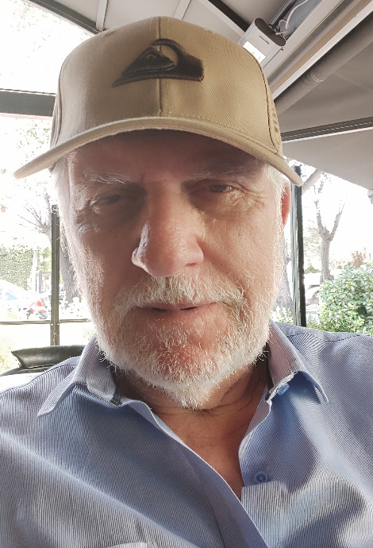

**Studies:**

**1961-1966:** Mechanical & Electrical Engineer, National Technical University of Athens (NTUA)  
**1976-1979:** PhD, Imperial College, London University (Scholar of Greek National Scholarship Foundation

**Academic Career:**

* **1970-1975:** Professor, University of West Attica (Electrical technology)
* **1979-2010:** Associate Professor, NTUA (Electromechanical systems of Thrust & Power)
* **1986-1989:** Senate Member of NTUA
* **1987-1988:** Member of Executive Committee, Chania Technical University

**Main Scientific Papers:**

[Profile](https://www.researchgate.net/profile/Christos-Papageorgiou-3/stats)[https://www.researchgate.net/profile/Christos-Papageorgiou-3/](https://www.researchgate.net/profile/Christos-Papageorgiou-3/stats)research

* **Research Interest Score:** 329.2
* **Citations:** 591
* **h-index:** 14

**Professional Management Career:**

**Primary Governmental Positions:**

* **1981-1983:** Deputy CEO, National Hellenic Railways
* **1983-1985:** CEO, OLYMPIC AIRWAYS
* **1986-1987:** CEO, PYRKAL (Main Defense Industry in Greece)
* **1988-1989:** CEO, National Hellenic Railways
* **1994-1995:** Chairman, “PAEGA” SA (subsidiary of “National Bank of Greece”)
* **1996-1997:** Chairman, National Hellenic Railways

**Primary Private Sector Positions:**

* **1990-1996:** Member of Board, “VERNICOS YACHTS” S.A.
* **2000-2004:** President, VERAVIA S.A. (express freight airline company)

**Academic Interests:**

* Solar Chimney Technology (Inventor of Hybrid PV+ Solar Chimney technology)
* Energy Systems
* Electromagnetic Applications for Power and Propulsion Systems
* Electro-Magnetic Theory and Quantum Mechanics
* Low Energy Nuclear Reactions (LENR) Technologies

**Recent Business Activities:**

* CEO, [PAP-LENR Company](https://www.pap-lenr.com/) (focused on Low Energy Nuclear Reaction - LENR)
* Partner, [KVL Electric P.C.](https://www.kvlelectric.com/)

**Hobbies:**

* Mathematics
* Philosophy
* History

**Published Books at NTUA:**

1. *Ευθύγραμμοι Κινητήρες* (Linear Motors)
2. *Κύματα- Από τον Ηλεκτρομαγνητισμό στην Κβαντομηχανική* (Waves-from Electromagnetism to Quantum Mechanics)

This enhanced CV provides a clear and comprehensive overview of Prof. Christos D. Papageorgiou's academic and professional journey, research interests, and recent business activities. The inclusion of key achievements, positions held, and published works contributes to a well-rounded presentation of his expertise and contributions to various fields.